Assignment 10

Q1)

For this question I will first download the code from the link given to use the file called simple.

Then doing the process in workshop 10 I used Ghidra to find the password. From Ghidra I was able to see the formula of local_14 and the values for local_c and local_10.

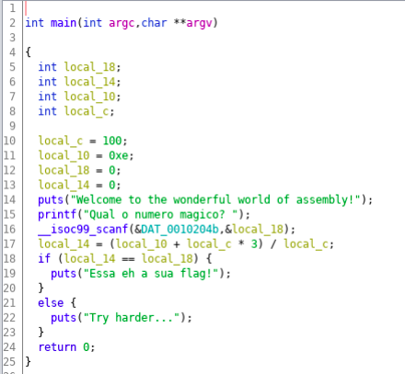

Then I calulate the value of local_14 is 3 in hex.

After in the 64bit Linux I will run the command chmod +x on the file simple to avoid the message stating permission denied.

Following this I will run the simple file by typing ./simple and will type "3" after the question mark. Then doing this gave me the "Essah eh a sua flag!" message.

After this I wrote in the terminal 3abcdefghijkl and also resulted in the message "Essah eh a sua flag!"

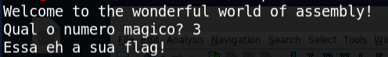

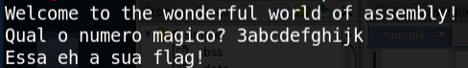

Q2)

For Q2 I will first downlaod the word document provided from the link and then extracted the file and get some folders.

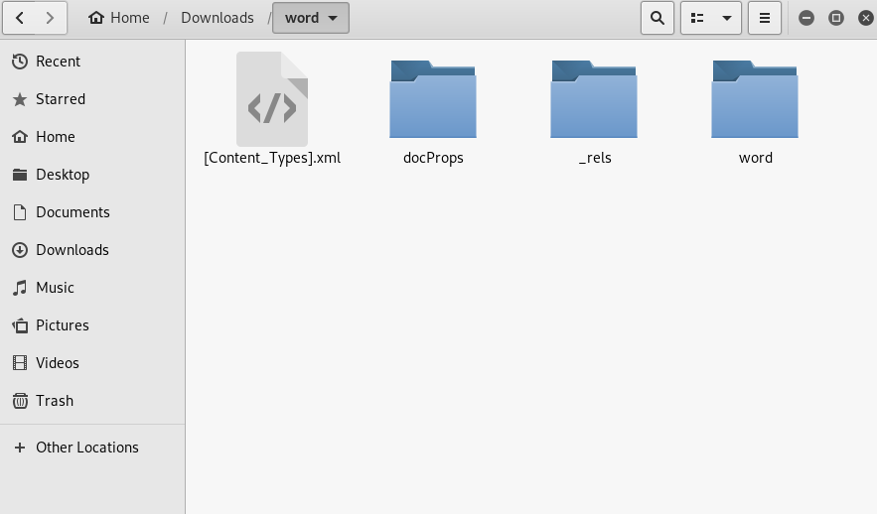

As i went inside the /word/word/media directory I found a file called image1.PNG

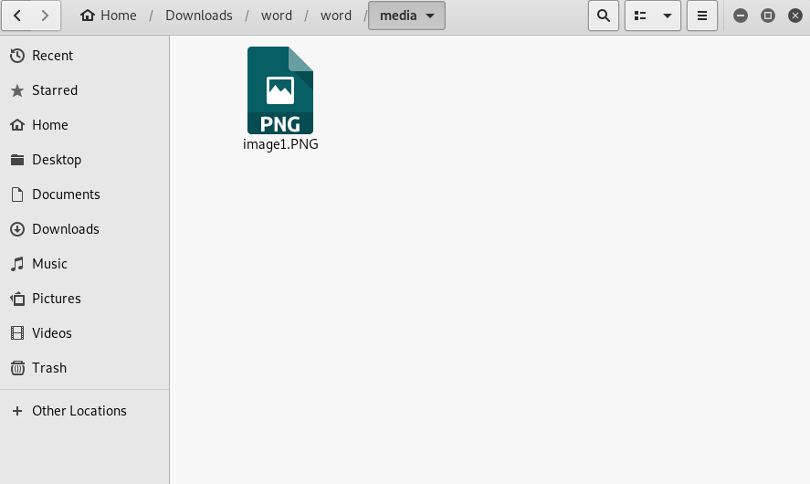

And then I load this file to Stegsolve but it failed and then I ran the command file image1.PNG and also did cat image1.PNG. From this I understood that image 1 is not a PNG file but an ascii file.



Then I used the base64 command to decode the string which ends in "=".

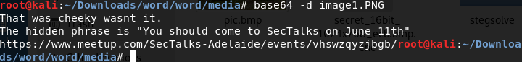

Q3)

* What was the main users Windows Username? and other email/s used for cloud services?

Users Window Username is jcloudy.

The emails :

jimcloudy@outlook.com

jimcloudy1@gmail.com

* What is the Processor Architecture and computer name?

Architecture- AMD64

Computer name- DESKTOP-PM6C56D

* What is an LNK file? What does it do? Give an example from the provided image?

LNK file is a file extension for a shortcut file used by Microsoft Word to point to an executable file and it has the direction to the executable file.